New Customer Registration

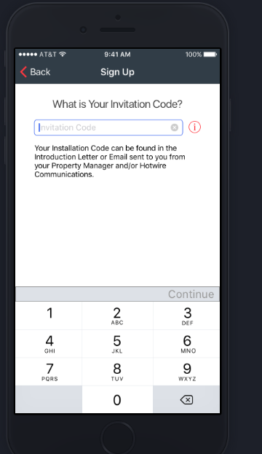

- Call SP_Get_InvitationCode with invite code
- Receive result of SP_Get_InvitationCode for pre-filling the customer name, email, phone, etc. if they are pre-loaded in the system when the customers sites are generated for a new property.
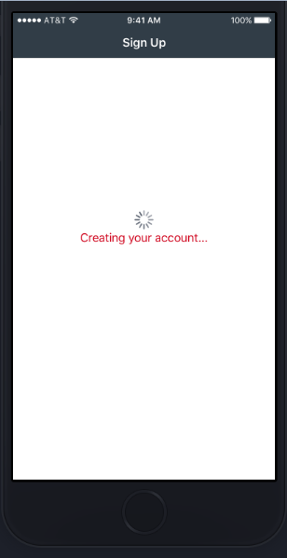

- Call the SP_Insert_AccountRegistration procedure to create the account, pass all the information gathered from the previous screens, by default set the IsHeadOfHousehold to true. Pass the synacore cloud ID that was created by ID management software

Existing Customer Registration

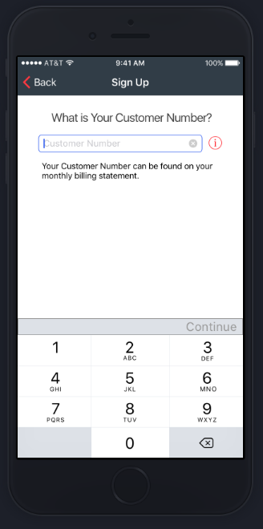

- Call sp_get_userdata with the customer number from the screen. The lookup will return a record if the user was pre-loaded into the system from Commosft / intranet.
- If the record exists all of the necessary user infromation is returned from the procedre for pre-filling the remaining screens of the existing customer registration process.

Push Notification

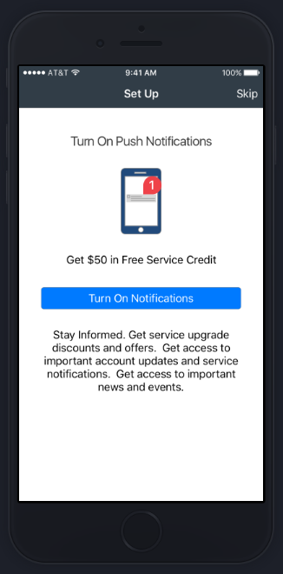

- Call the SP_Update_Pushnotification stored procedure and pass it the userid and the enable boolean to turn the notifications on / off.

Contact Verification

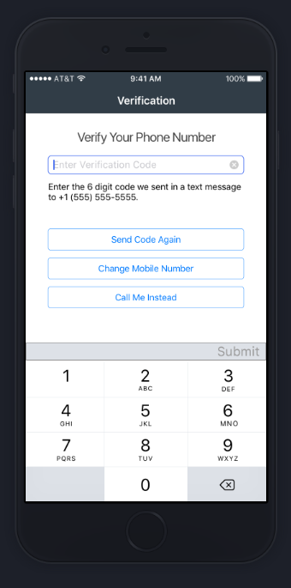

- When a phone or email is verified, call the SP_Verify_Contact procedure with the UserID and IsVerified Boolean and the V_ListType code specifying the type of contact being verified.

